**QUESTION: IMDB Design a DB for IMDB**

**Ans:**

**Create:**

create table imbd(

name text,

image blob,

genre text,

reviews integer,

artist text

);

**Update:**

insert into imbd values("Batman","C:\Users\Praveen\OneDrive\Pictures\put.png","Superhero film",8.2,"Robert Pattinson");

insert into imbd values("Superman","C:\Users\Praveen\OneDrive\Pictures\superman.png","Superhero film",7.2,"Christopher Reeve");

insert into imbd values("Spiderman","C:\Users\Praveen\OneDrive\Pictures\spiderman.png","Superhero film",9.2,"Tobey Maguire");

**Select:**

select * from imbd

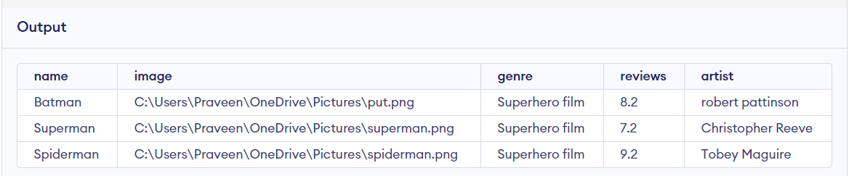

**Question 1. Movie should have multiple media(Video or Image)**

**Ans:**

**Create:**

create table images(

moviename text,

image blob

);

**Update:**

insert into images values("SpiderMan","C:\Users\Praveen\OneDrive\Pictures\spiderman.png");

insert into images values("SuperMan","C:\Users\Praveen\OneDrive\Pictures\superman.png");

insert into images values("CaptainAmerica","C:\Users\Praveen\OneDrive\Pictures\captainamerica.png");

**Select:**

select * from Images;

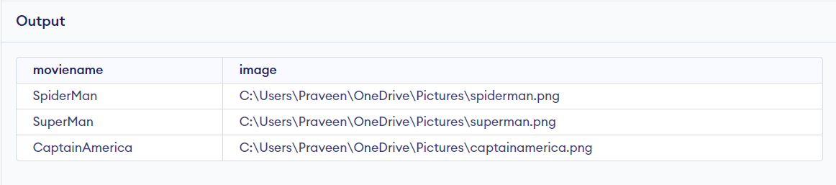

**Question 2. Movie can belong to multiple Genre**

**Ans:**

**Create:**

create table genre(

moviename text,

genre text

);

**Update:**

insert into genre values("Spiderman”, Superhero film");

insert into genre values("Ghosted”, “Action");

insert into genre values("Bad Hair”, “Horror");

Select:

select * from genre

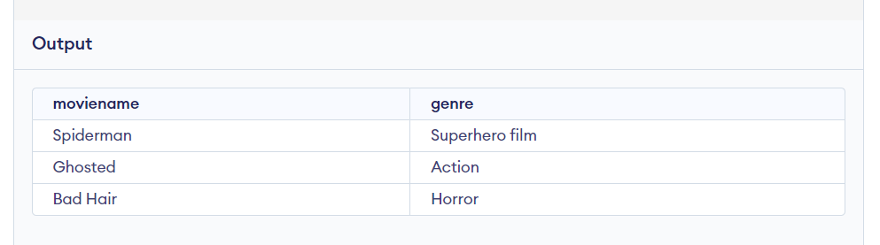

**Question 3. Movie can have multiple reviews and Review can belongs to a user**

**Ans:**

**Create:**

create table reviews(

moviename text,

reviews integer,

user text

);

**Update:**

insert into reviews values("Spiderman",9.2,"Anirutha");

insert into reviews values("Superman",8.2,"Praveen");

insert into reviews values("Superman",8.2,"Praveen");

**Select:**

select * from reviews;

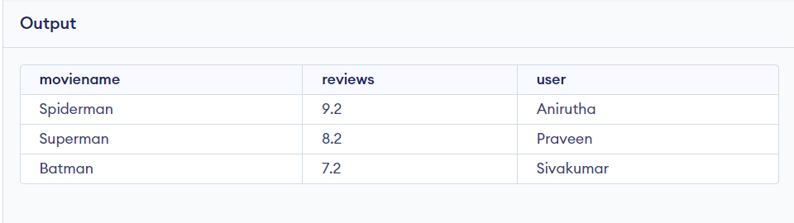

**Question 4. Artist can have multiple skills**

**Ans:**

**Create:**

create table artist(

name text,

skills text

);

**Update:**

insert into artist values("Robert Pattinson”, “Singing");

insert into artist values("Christopher Reeve”, “Dancing");

insert into artist values("Tobey Maguire”, Drawing");

**Select:**

select * from artist

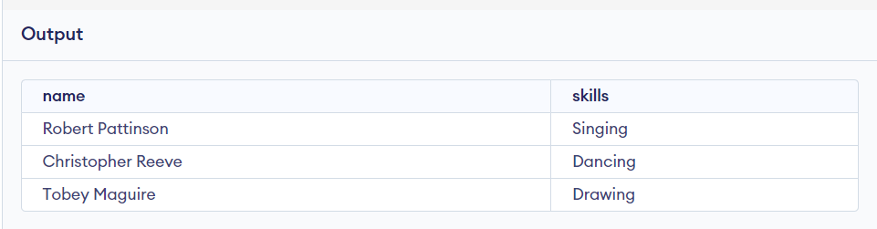

**Question 5. Artist can perform multiple role in a single film**

**Ans:**

**Create:**

create table role(

moviename text,

heroname text,

role1 text,

role2 text

);

**Update:**

insert into role values("Dasavatharam","Kamal","Govind","Balram");

insert into role values("Enthiran","Rajinikanth","Vaseegaran","Chitti");

**Select:**

select * FROM ROLE

